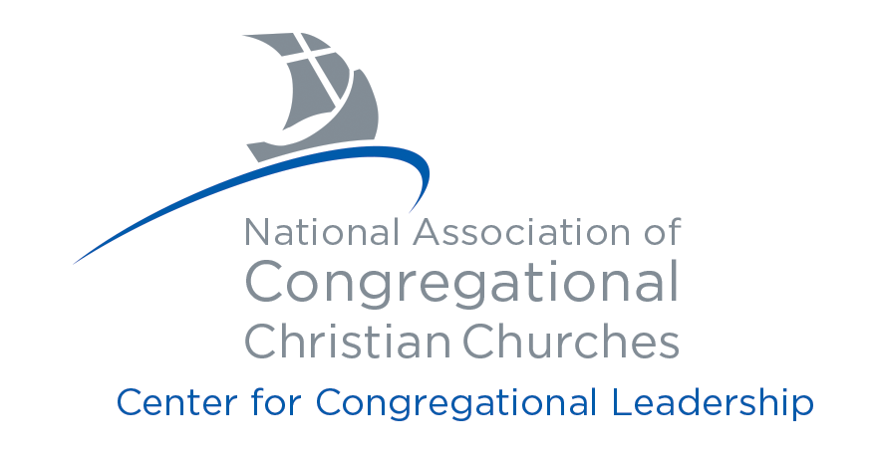

LAY MINISTRY TRAINING PROGRAM
Supplemental Information
Application Form Due July 1
Complete and upload to your Online Application form

Upon completion, upload this Supplemental Information form and two reference letters to the Online Lay Ministry Training Program Application. Follow the instructions found at the end of this form.

GENERAL INFORMATION
First Name | Middle Initial | Last Name

PROGRAM GOAL
I am interested in the Lay Ministry Program so that I may:

EDUCATION
Do you have a high school education or equivalency? Yes ______ No _______
Please provide the following information for any college, university or seminary you attended upon graduation from high school.

Name of institution, location, and degree:

EMPLOYMENT HISTORY

Please describe your professional and work background:

ACTIVITIES (Boxes will expand as needed).

Please list significant experience with:

Religious Activities:

Civic, Social or Educational Activities:

Special Interests or Hobbies:

Special abilities or skills that will benefit your calling:

Academic, civic, military or other distinctions, recognitions or awards received:

Publications or presentations of significance, dates:

ESSAYS (Boxes will expand as you type.)
Please share your faith journey in 1000 words or less.

What are the challenges, expectations and rewards you anticipate in this Lay Ministry Training Program?

Why are you drawn to the Congregational Church? Be specific as to why the Congregational Way is a good fit for you.

Do you feel God is calling you to a particular role in ministry? If yes, what role?

List the names of three people whom you would consider as your local mentor, and briefly describe how long you’ve known them.

Complete the following only if you are not affiliated with a NACCC Member Church:

What about the NACCC Lay Ministry Program is attractive to you?

What are you hoping to gain by participating?

Submitting this Form
After completing this Supplemental Information form, make certain you have collected the following letters. You will be asked to attach (upload) this form and both letters to your ONLINE Application.

- Letter from your minister or if you are currently a minister or your church does not have a minister, a letter from a ministerial colleague (preferably a Congregational colleague), indicating that you have counseled with him/her regarding your intention to enter the Lay Ministry Training Program and that he/she agrees that you have the natural and spiritual gifts necessary to function as a lay minister and that your personal life gives evidence to a call to the lay ministry.

- Letter of recommendation for admittance from the Board of Deacons, or an equivalent board, of your local church which states in the opinion of the members of this board you are a suitable person, given the training and opportunity, to serve a church as a lay minister.

Once you have all three documents, you are now ready to finalize your application. The ONLINE Lay Ministry Training Program application can be found by clicking here.

Please Note

- A $50 non-refundable application fee, payable with a credit card, will be required for your application to be reviewed.

- Upon approval into the program, you will be contacted and asked on behalf of the NACCC member churches to complete a consent form for a background check. (consisting of, Nationwide Criminal Super Search, Nationwide Sex Offender Registry Search, Social Security Trace Plus, and Statewide/County Criminal Search.) Such a search will be conducted by its designated agent. A consent form will be provided for you to complete and sign upon final approval into the program.

- It is understood that, if accepted into the Lay Ministry Training Program of the National Association of Congregational Christian Churches, full communication is expected among instructors, local and cohort mentors, and the Editorial Board, regarding matters related to my academic progress or general involvement in the program.

For more information, contact:
National Association of Congregational Christian Churches
Attn: Laura Wright
8473 S Howell Ave, PO Box 288
Oak Creek, WI 53154
1-800-262-1620 x1614
Email: lwright@naccc.org

